💡 Organized Technical To-Do List by Theme
I've organized the complete list of tasks into thematic categories to make it easier to see the areas of focus.

🐍 Python and Utility Scripts
These tasks focus on using Python for automation, file management, and reporting.
- 37. Python program to use different option to do folder copy efficiently on Windows
- 38. Python program to convert PDF to Image and vice-versa
- 39. Python program to combine boundaries and Generate Report
- 40. Python program to find the list of users connected to current IP and All IP
- 41. Python program to find the List of files committed based on Commit ID and PR ID
- 42. Python program to search String in All Bitbucket repo code
- 44. Python program to switch the branch and pull latest code
- 5. Write simple Utility to identify duplicate files
- 13. Write a simple utility - stand alone for Bulk file process

🛠️ Development Tools and Workflow (Git, Eclipse, POM)
These tasks relate to integrating, automating, and managing the development environment.
- 24. Integrate git with Eclipse separate workspace - git local branch with multiple remote branches and swtch code seemlessly
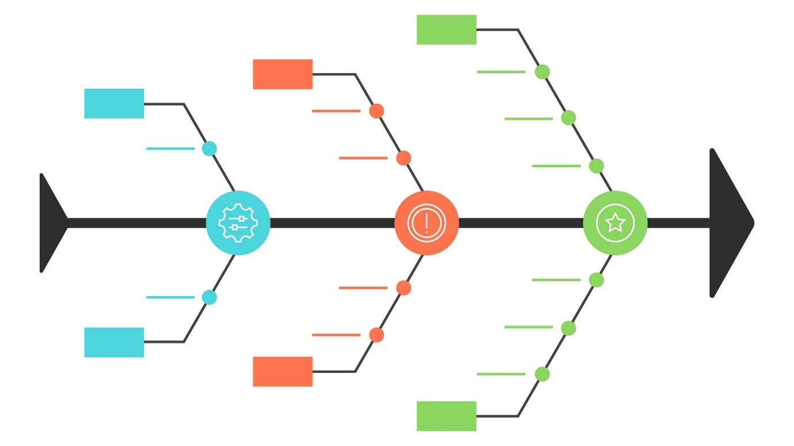Opens in a new window
Shutterstock
- 25. Learn to create patch from Eclipse for changed files
- 34. Automate to get the Files differed between two commits using git commands
- 36. In POM Swsed project where Multiple modules involved how to quickly identify Module with pat commiting other modules to parot POM
- 46. Automate the process of updating ear file with Hotfix files, and automate the deployment of files in the server for.
- 4. Find java Method Ref. usage recursively from Entry Method of a class

💻 System Automation (Shell, Batch, Environment)
Tasks involving command-line scripting and environment setup.
- 12. Write Unix Shell scripts to connect to an external system, fetch/download files etc.
- 18. Write Unix Shell scripts using
- 26. Using Shell Script to get the SIT ear file, APP data, customize and deploy in development server
- 10. Convert Environment re-produce batch command in Excel or create batch file externalizing Input folder
- 16. List of Batch/Daily/Monthly jobs and corresponding tables
- 45. For Batch program, if log files are being fetched using sftb, before fetching log from SIT check the log file existing is of less than one hour or file not exist, then fetch from SIT server using SFTP. If log is fetched less than hour then, don't call SIT server and process the SIT Log from DEV server.
- 47. For batch programs, write test program and run on Dev machine to validate DB connection is getting from Wallet connection.

📊 Data, Reporting, and Validation
Tasks focused on data manipulation, formatting, security, and generating reports/dashboards.
- 1. Approach for Flat file parsing and Flat file Generation using standalone application with Help of UOB Formatter classes and generate simple Key value mapping
- 6. Write a simple Web page for JSON and XML Formatting
- 7. Generate JSON and XML Schema
- 29. Generate tool to validate the XML Message Generated and Received that goes comes in from IDB / EAI and goes Out to EAI and IDB
- 32. Utility to Generate DTD based on Excel Mapping sheet - so that can validate the XML against DTD
- 22. Prepare Dashboard based on past Inc list - Categorize Country - Function - Number of Issues function Wise
- 23. For VN r-tax - Change Value date in Narrative using Reg Ex pattern replace ment and write as separate Simple Method
- 17. Write automated program to connect to vault and read password
- 19. Generate sample file for BWC with CIF details

🧩 Process and Impact Analysis
Tasks aimed at understanding system behavior, dependencies, and change management.
- 2. How to identify the DB tables impacted when executed any portal function or Deacon process of Batch Process Ran
- 3. How to Mitigate DTAAS Limitation of non-persistence when get restarted
- 30. Write a Tool to generate call hierarchy for a given method to speed the Impact
- 33. Automated program to list the HandOff Number and files impacted as part of the HandOff
- 35. Automated program to get the files and code differed between two programs to find possible differences
- 21. Migration scripts for roles, permission etc.

🕸️ API, Web, and Excel Integration
Tasks covering API interaction and leveraging Excel for various functions.
- 14. List of API's and corresponding swagger/postman/curl
- 15. Excel Macro to trigger the API using CURL command or open in Browser
- 43. Create Node-Express is project to expose all micro services through web application
- 8. Excel Macro to Open URL in Browser
- 9. Excel Macro to call application URL
- 11. Write Excel Macro to call console commands bind's to find and opere quickly
- 20. Prepare sample script to read the Excel file and import to DB

💡 Organized Technical To-Do List by Theme (Serial Numbers Reset)
I have corrected the serial numbering to start from 1 within each thematic category for improved readability.

🐍 Python and Utility Scripts
These tasks focus on using Python for automation, file management, and reporting, plus general utility creation.
- Write simple Utility to identify duplicate files (Original Task #5)
- Write a simple utility - stand alone for Bulk file process (Original Task #13)
- Python program to use different option to do folder copy efficiently on Windows (Original Task #37)
- Python program to convert PDF to Image and vice-versa (Original Task #38)
- Python program to combine boundaries and Generate Report (Original Task #39)
- Python program to find the list of users connected to current IP and All IP (Original Task #40)
- Python program to find the List of files committed based on Commit ID and PR ID (Original Task #41)
- Python program to search String in All Bitbucket repo code (Original Task #42)
- Python program to switch the branch and pull latest code (Original Task #44)

🛠️ Development Tools and Workflow (Git, Java, Eclipse, POM)
These tasks relate to integrating, automating, and managing the development environment and source code analysis.
- Find java Method Ref. usage recursively from Entry Method of a class (Original Task #4)
- Integrate git with Eclipse separate workspace - git local branch with multiple remote branches and swtch code seemlessly
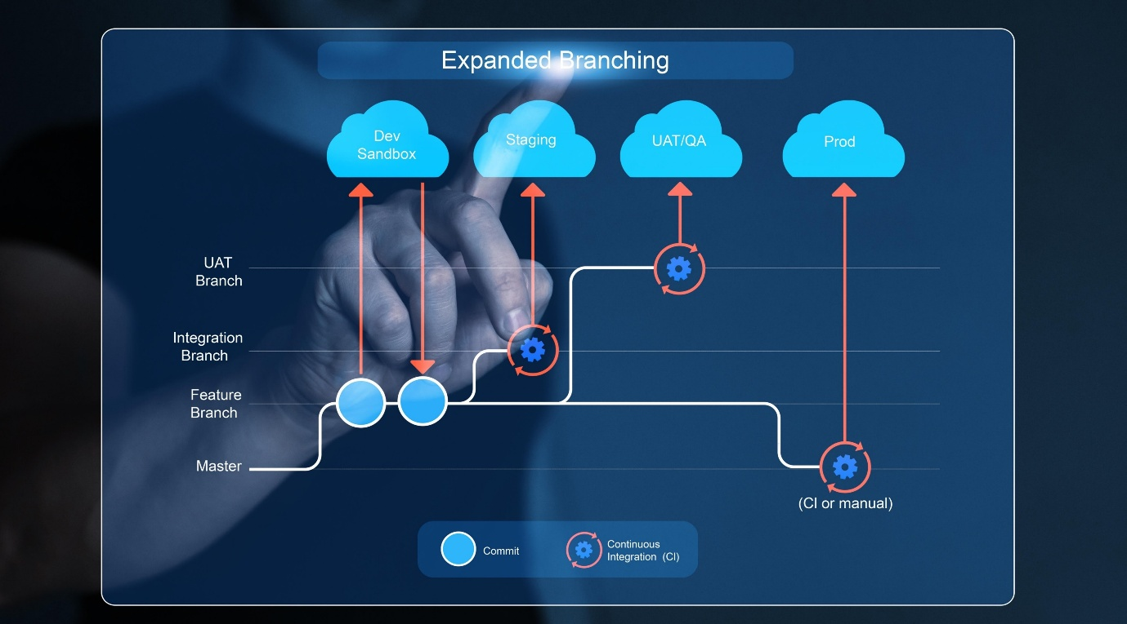
Shutterstock
(Original Task #24)
3. Learn to create patch from Eclipse for changed files (Original Task #25)
4. Automate to get the Files differed between two commits using git commands (Original Task #34)
5. In POM Swsed project where Multiple modules involved how to quickly identify Module with pat commiting other modules to parot POM (Original Task #36)
6. Automate the process of updating ear file with Hotfix files, and automate the deployment of files in the server for. (Original Task #46)

💻 System Automation and Infrastructure
Tasks involving command-line scripting, environment setup, and secure access.
- Convert Environment re-produce batch command in Excel or create batch file externalizing Input folder (Original Task #10)
- Write Unix Shell scripts to connect to an external system, fetch/download files etc. (Original Task #12)
- Write automated program to connect to vault and read password (Original Task #17)
- Write Unix Shell scripts using (Original Task #18)
- Using Shell Script to get the SIT ear file, APP data, customize and deploy in development server (Original Task #26)

📊 Data, Reporting, and Validation
Tasks focused on data manipulation, formatting, validation, and generating reports/dashboards.
- Approach for Flat file parsing and Flat file Generation using standalone application with Help of UOB Formatter classes and generate simple Key value mapping (Original Task #1)
- Write a simple Web page for JSON and XML Formatting (Original Task #6)
- Generate JSON and XML Schema (Original Task #7)
- Generate sample file for BWC with CIF details (Original Task #19)
- Prepare sample script to read the Excel file and import to DB (Original Task #20)
- Prepare Dashboard based on past Inc list - Categorize Country - Function - Number of Issues function Wise (Original Task #22)
- For VN r-tax - Change Value date in Narrative using Reg Ex pattern replace ment and write as separate Simple Method (Original Task #23)
- Generate tool to validate the XML Message Generated and Received that goes comes in from IDB / EAI and goes Out to EAI and IDB (Original Task #29)
- Utility to Generate DTD based on Excel Mapping sheet - so that can validate the XML against DTD (Original Task #32)

🧩 Process, Impact Analysis, and Migration
Tasks aimed at understanding system behavior, dependencies, change management, and database-related processes.
- How to identify the DB tables impacted when executed any portal function or Deacon process of Batch Process Ran (Original Task #2)
- How to Mitigate DTAAS Limitation of non-persistence when get restarted (Original Task #3)
- List of Batch/Daily/Monthly jobs and corresponding tables (Original Task #16)
- Migration scripts for roles, permission etc. (Original Task #21)
- Write a Tool to generate call hierarchy for a given method to speed the Impact (Original Task #30)
- Automated program to list the HandOff Number and files impacted as part of the HandOff (Original Task #33)
- Automated program to get the files and code differed between two programs to find possible differences (Original Task #35)
- For Batch program, if log files are being fetched using sftb, before fetching log from SIT check the log file existing is of less than one hour or file not exist, then fetch from SIT server using SFTP. If log is fetched less than hour then, don't call SIT server and process the SIT Log from DEV server. (Original Task #45)
- For batch programs, write test program and run on Dev machine to validate DB connection is getting from Wallet connection. (Original Task #47)

🕸️ API, Web, and Excel Integration
Tasks covering API interaction and leveraging Excel for various functions.
- Excel Macro to Open URL in Browser (Original Task #8)
- Excel Macro to call application URL (Original Task #9)
- Write Excel Macro to call console commands bind's to find and opere quickly (Original Task #11)
- List of API's and corresponding swagger/postman/curl (Original Task #14)
- Excel Macro to trigger the API using CURL command or open in Browser (Original Task #15)
- Create Node-Express is project to expose all micro services through web application (Original Task #43)

